3) Previously 5c)

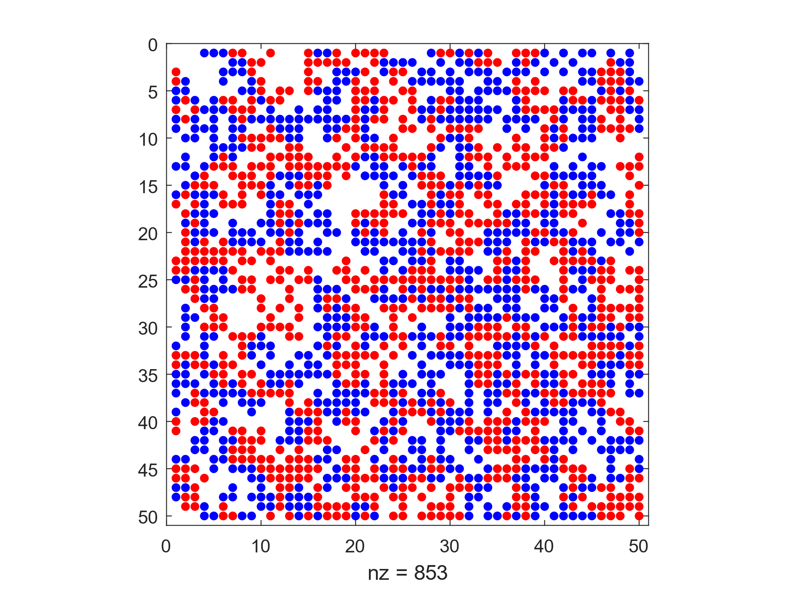

*Figure 14: Empty Ratio = 0.4, Similarity Threshold = 0.2*

Average similarity = 3.3716, Similarity Ratio = 0.4359

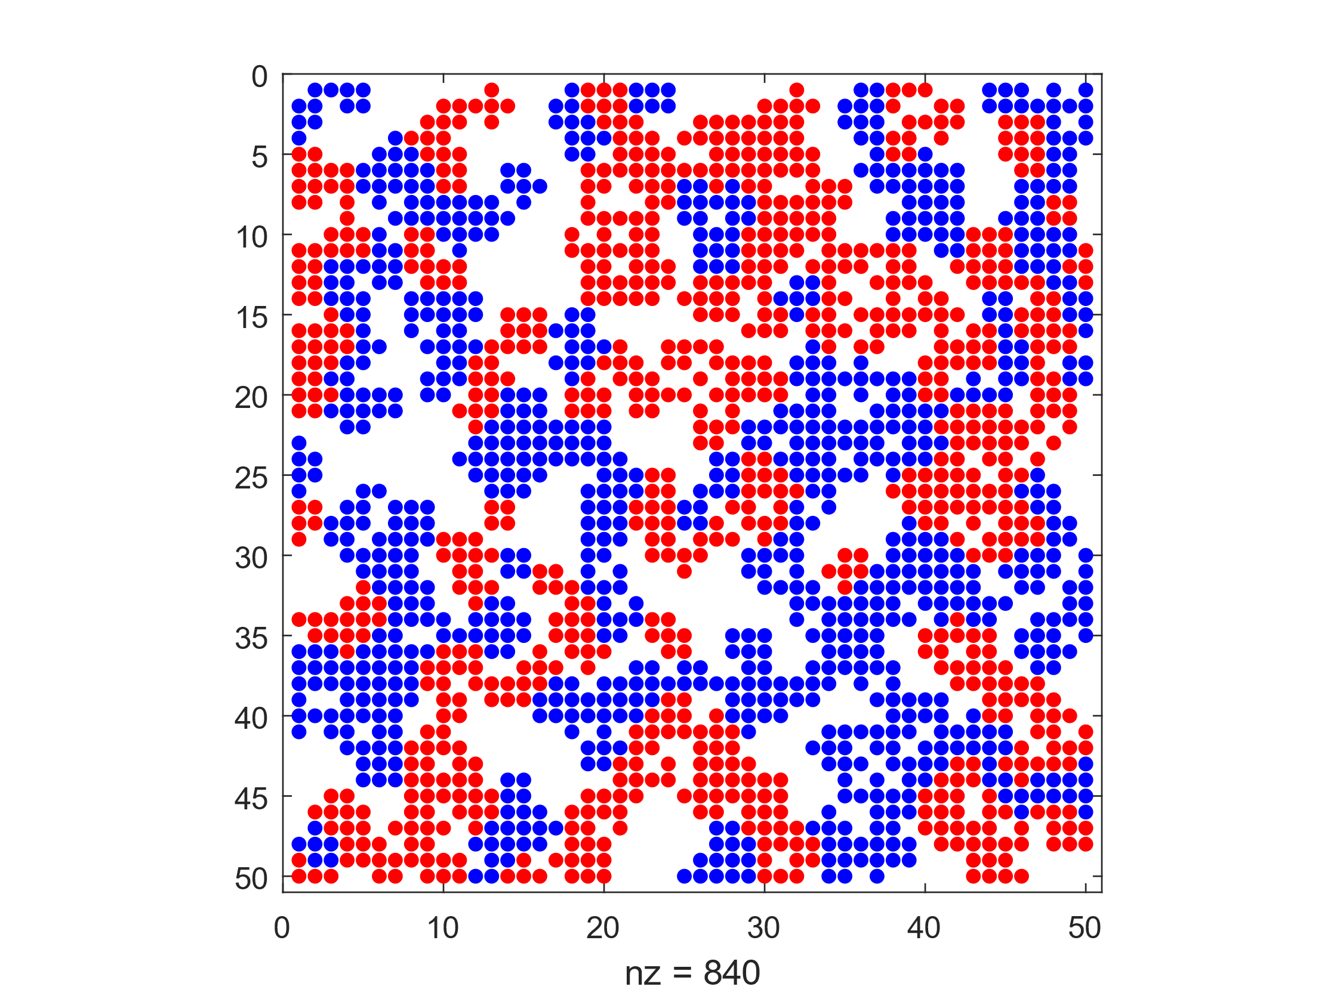

*Figure 15: Empty Ratio = 0.4, Similarity Threshold = 0.3*

Average similarity = 4.7468, Similarity Ratio = 0.6141

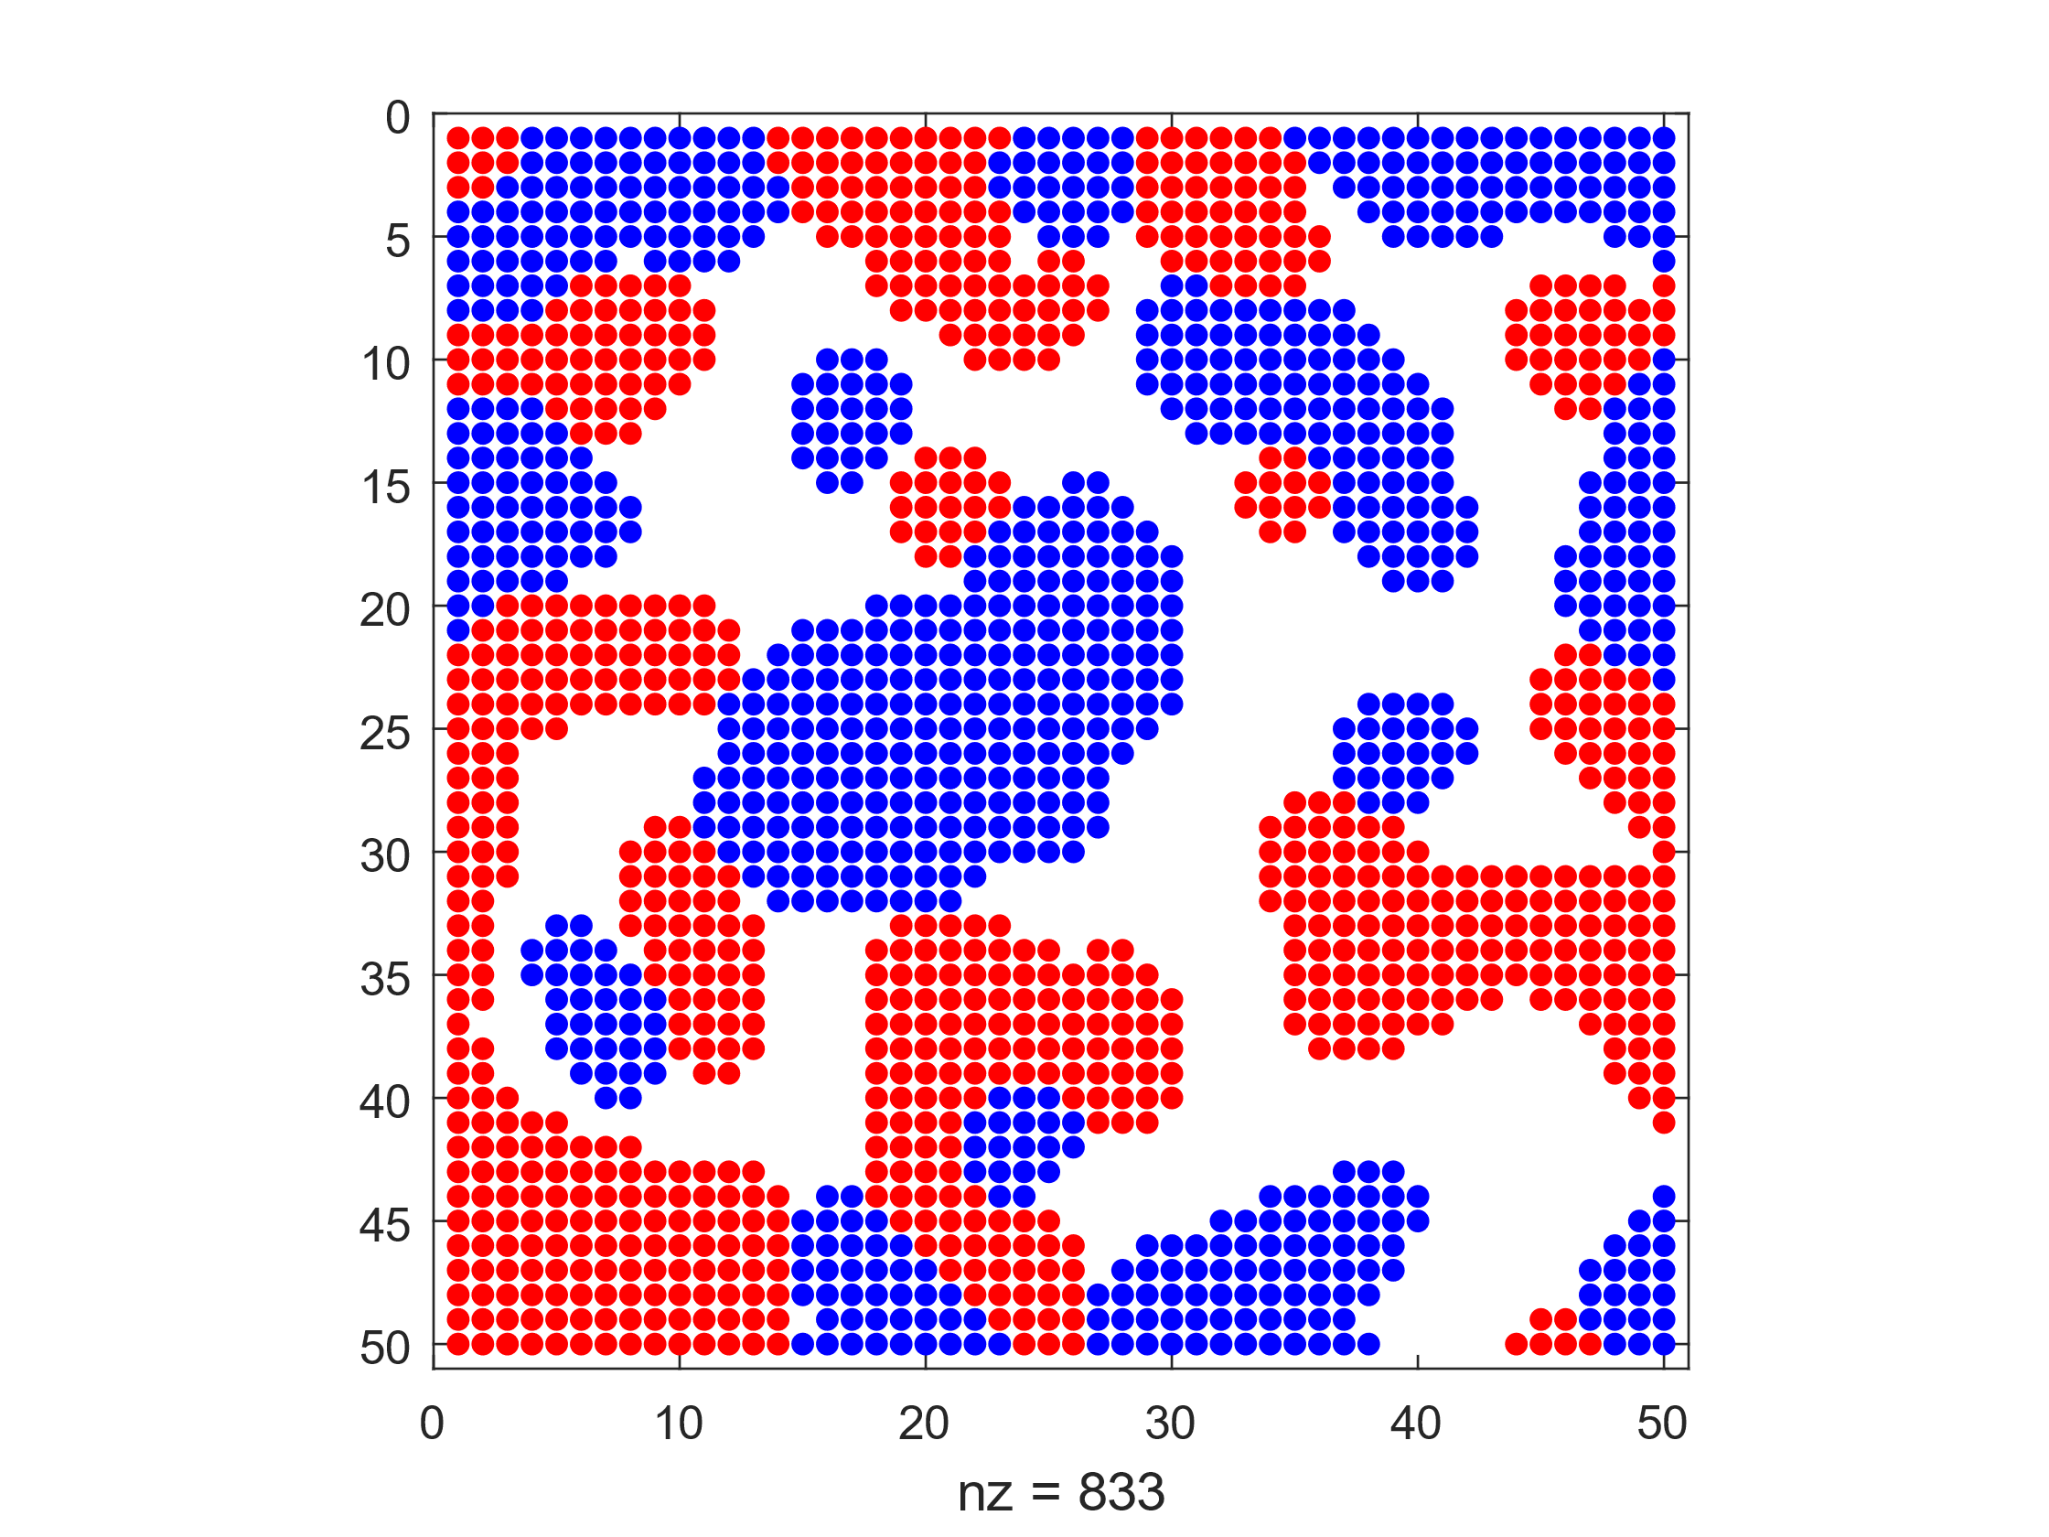

*Figure 16: Empty Ratio = 0.4, Similarity Threshold = 0.4*

Average similarity = 6.4284, Similarity Ratio = 0.8325

For each of these simulations, the Average similarity is the number of surrounding blocks of the same type. A theoretical max of 8 can be achieved for agents not on the edge of the model. For each of these models, the similarity ratio is higher than the similarity threshold and as such, these models have successfully converged.

5) a)

i. [1 (ALLD), 1 (ALLD), 1 (ALLD), 4 (GRIM)]:

Z =

200 200 200 203

200 200 200 203

200 200 200 203

199 199 199 600

Scores =

803 803 803 1197

The ALLD players lose in this scenario as the GRIM player does not give them any more points following their first defect. In the scenario when the GRIM player plays with another GRIM player, he manages to gain 600 points, which gives him the most overall points in the end when totalling scores. Thus, his score is much higher than those of the ALLD players.

ii. [2 (COOP), 2 (COOP), 2 (COOP), 1 (ALLD)]:

Z =

600 600 600 0

600 600 600 0

600 600 600 0

800 800 800 200

Scores =

1800 1800 1800 2600

This scenario heavily benefits the ALLD player as there are no repercussions for their cheating. The other player will always cooperate regardless of previous interactions. This allows the ALLD player to gain the maximum number of points, 4, each round. Thus, his total is much higher than that of the players who cooperated with each other with a gain of 3 each round.

iii. [1 (ALLD), 2 (COOP), 3 (TIT-4-TAT), 4 (GRIM)]:

Z =

200 800 203 203

0 600 600 600

199 600 600 600

199 600 600 600

Scores =

1406 1800 1999 1999

In this scenario, the ALLD player loses as the other players are responsive to his strategy. After the first time TIT-4-TAT and GRIM are cheated by the ALLD player, they switch strategy to mutually cheat. This prevents ALLD from maximizing their point gain in all scenarios except for when they compete against the COOP player. The COOP, TIT-4-TAT, and GRIM players will all cooperate as they will not defect at any point and as such, gain many points. The reason the COOP player has fewer points than those of TIT-4-TAT and GRIM is due to their lack of reaction to ALLD’s strategy, as such gaining no points from their rounds against ALLD.

iv. [1 (ALLD), 1 (ALLD), 2 (COOP), 3 (TIT-4-TAT)]:

Z =

200 200 800 203

200 200 800 203

0 0 600 600

199 199 600 600

Scores =

1403 1403 1200 1598

As in the case for ii) and iii), ALLD can abuse the COOP competitor and gain 800 points, however, the ALLD competitor also suffers against the adaptive strategy of the TIT-4-TAT competitor. The TIT-4-TAT competitor gains a considerable number of points due to their interaction with the COOP player, thus gaining many points in interactions with TIT-4-TAT and COOP players, while also not sacrificing many points when competing against the ALLD players.

b) BONUS:

[1 (ALLD), 2 (COOP), 3 (TIT-4-TAT), 4 (GRIM\*)]:

Z =

200 800 203 203

0 600 600 597

199 600 600 597

199 601 601 598

Scores =

1406 1797 1996 1999

The outcome of this test involving a GRIM\* competitor is most like that of iii). Due to the points gained due to outcomes of each strategy, the GRIM\* comes out slightly higher than the TIT-4-TAT player as the TIT-4-TAT player has no time to react to GRIM\*’s strategy. Since GRIM\* cheats in the last round, he is not penalised for his strategy. This allows him to cheat the other players out of points, thus increasing his score relative to the other player’s scores.